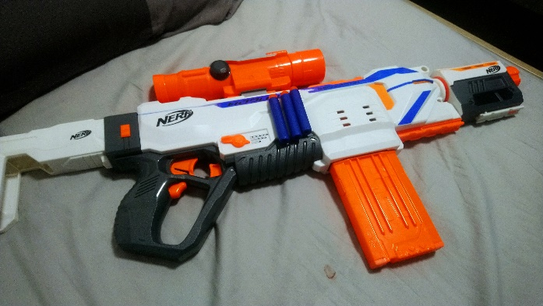Starting with a stock Nerf Regulator Blaser

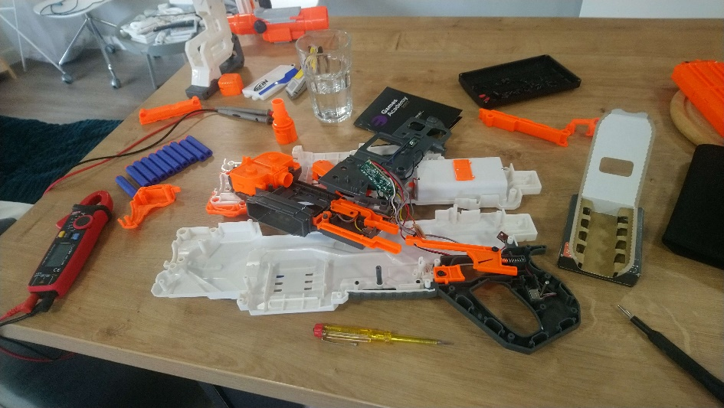

Take it completely to bits

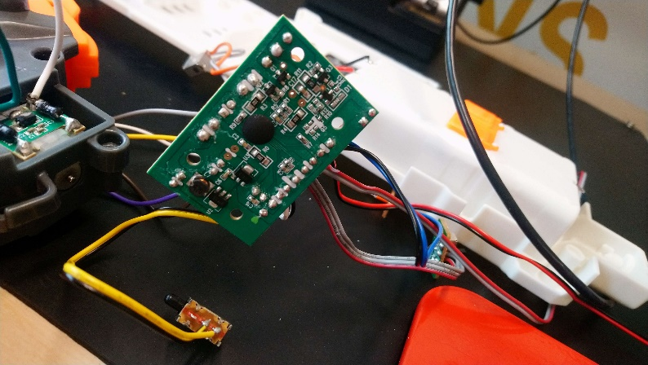

Reverse engineer the control board, what goes where, why so it can be replaced with an Arduino

It has a lot of wires.

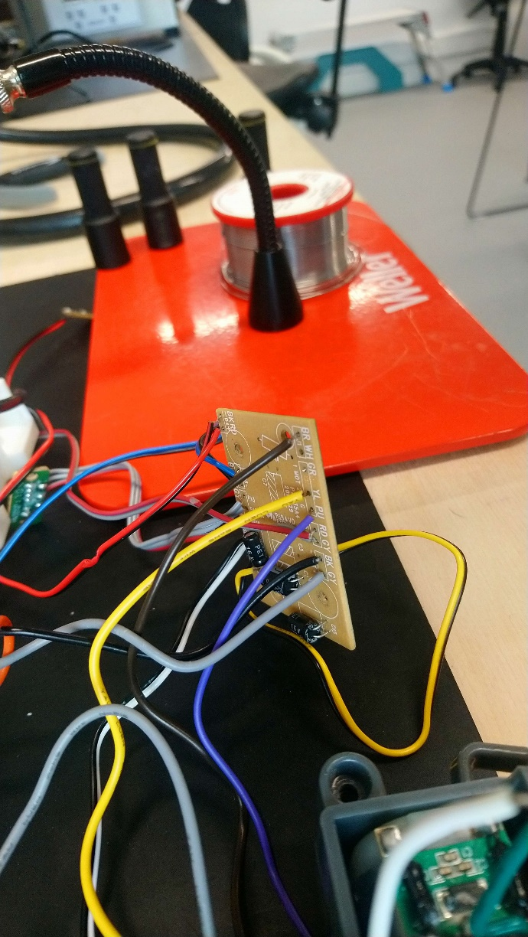

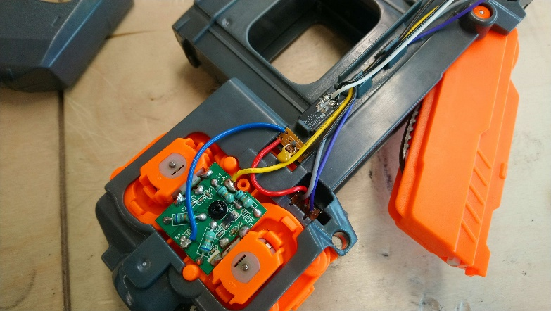The gun uses two fly wheel motors to accelerate the darts to high speed. There is also an extra motors which moves darts into the fly wheels from the magazine. Seen here is the pcb and the backs of the two fly wheel motors.

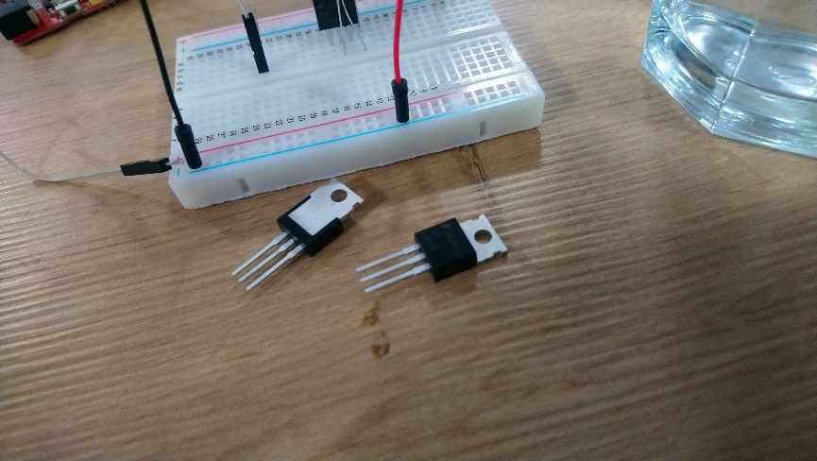Switching power on and off to motors is tricky, the switches need to with stand lots of current. I need an electric switch which can handle that current and can be switched on and off by the Arduino.

A big mosfet is the answer, these are rated for 32 amp continuous current. Significatly oversized for what I need, the motors in the nerfgun pull about 2amps when they start up. An electric motor pulls extremely high current when they start, once at speed the consume significantly less power.

De soldered everything from the main control board.

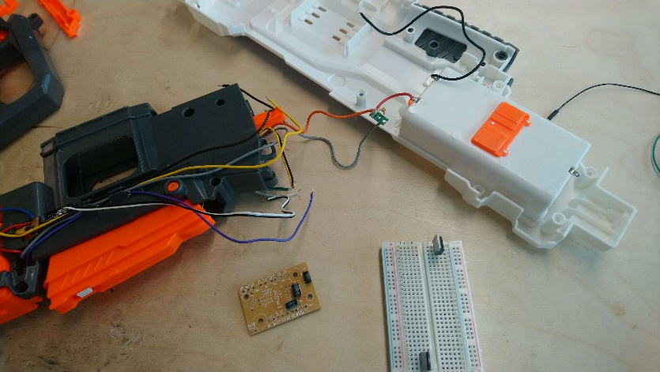

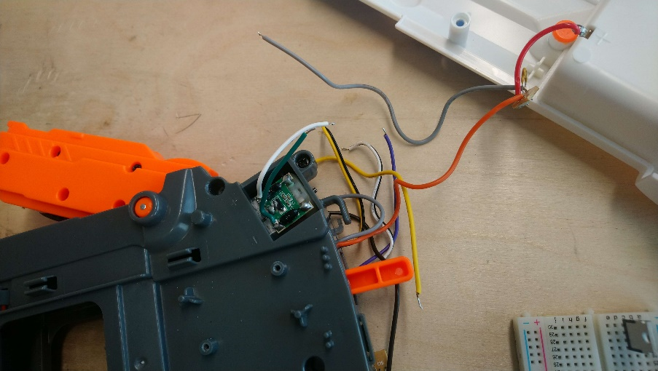

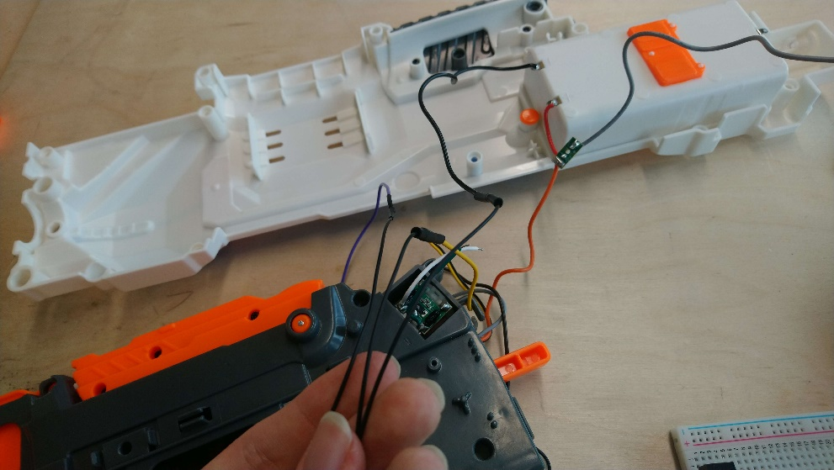

Some wiring clean up, everything connected to ground is black.

Also soldered on jump cables to the ends of the desoldered cables

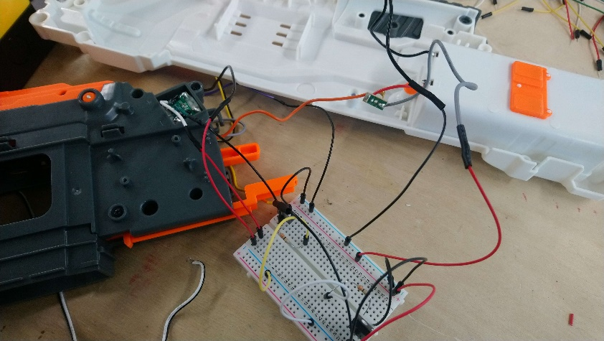Started trying to wire it up to the bread board

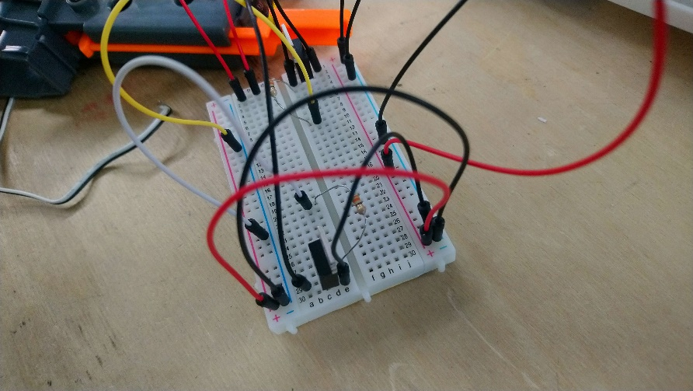

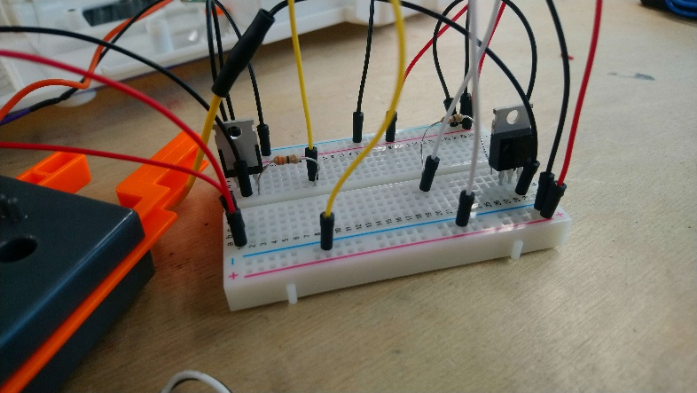

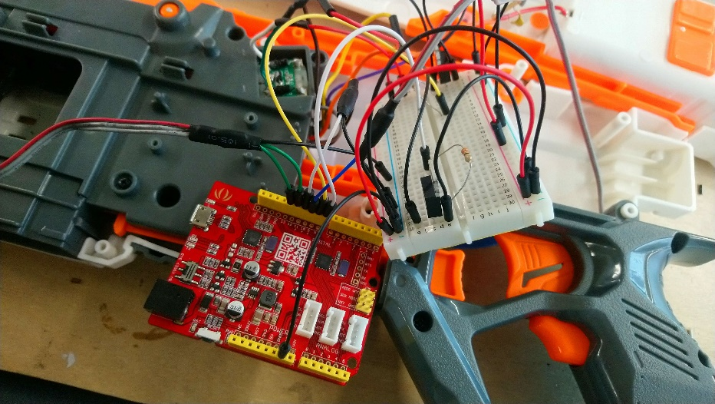

It only gets more complicated when you introduce an Arduino

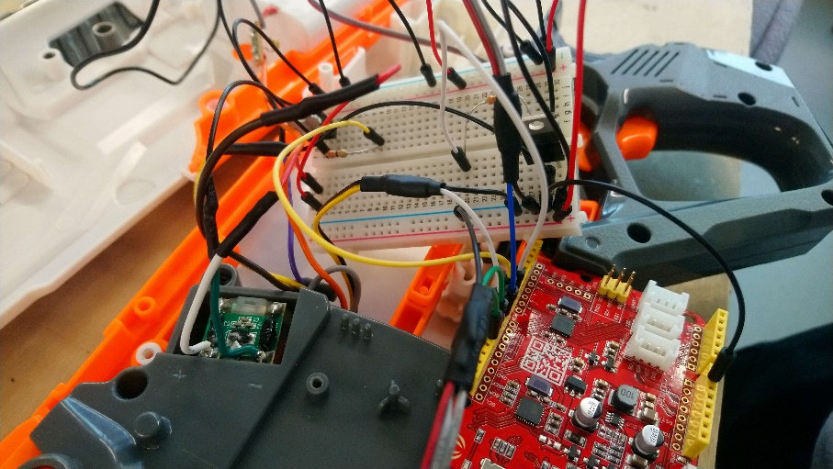

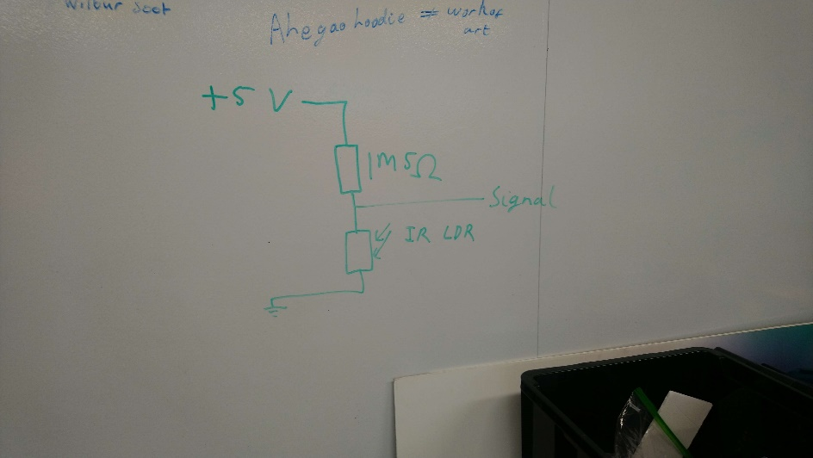

The gun has an ammo detector which uses an IR led and IR LDR Ben the lab technician helped me come up with a potential divider circuit to determine if ammo was present or not.

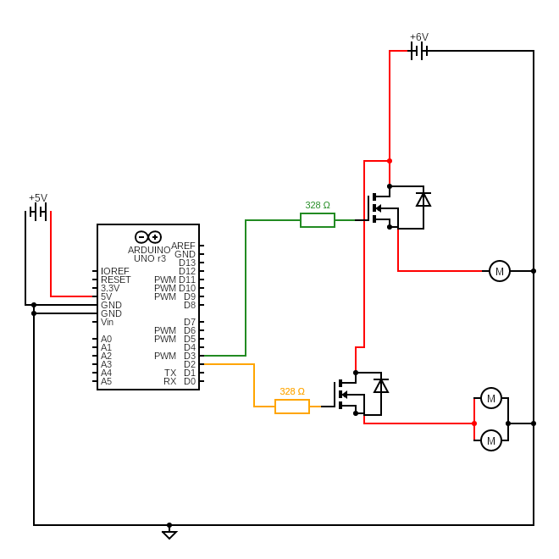Circuit diagram showing how the motors could be connected. This would later change to the mosfets switching motor ground rather than motor +6V.

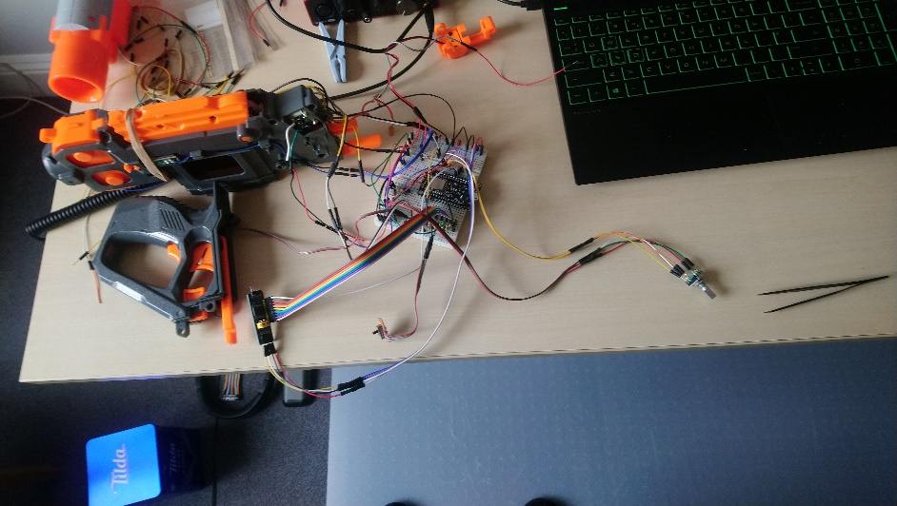Now with more components comes this breadboard prototype, using two breadboards.

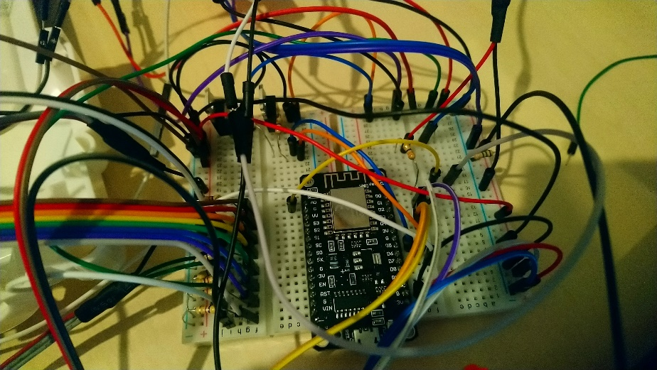Other components include an ESP8266/Node MCU – this will be replacing my Arduino for control. This chip is faster, has more memory and can connect to wifi. Also added is a PCF8574 IO expander board as the ESP8266 has fewer IO pin than the Arduino.

Close up of the breadboards and the ESP8266. The giant ribbon of rainbow is where the PCF8574 expander connects up.

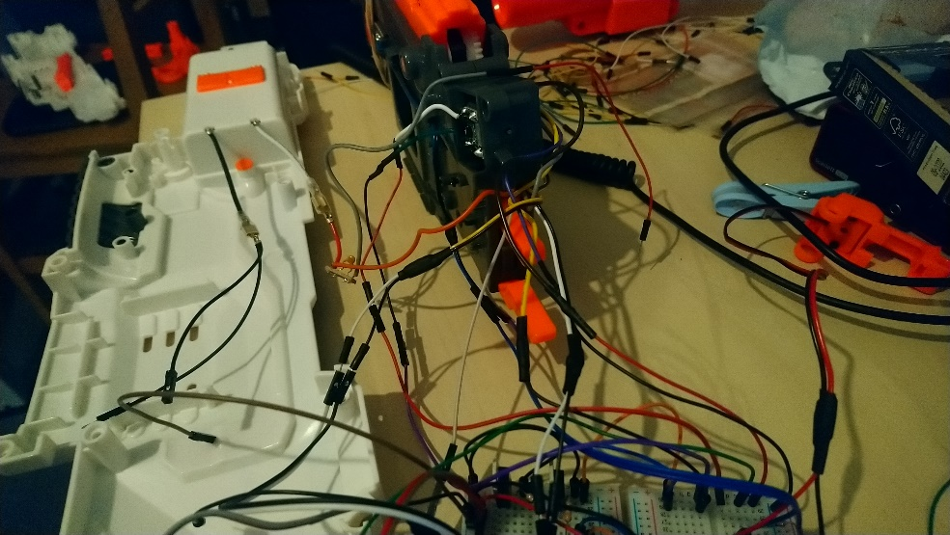This really is a prototype, it barely worked and it was hopelessly impractical

See the videos folder for evidence of this monstrosity actually working.

The prototype I transcribed into this schematic I made using KiCad (see poster for clearer version)

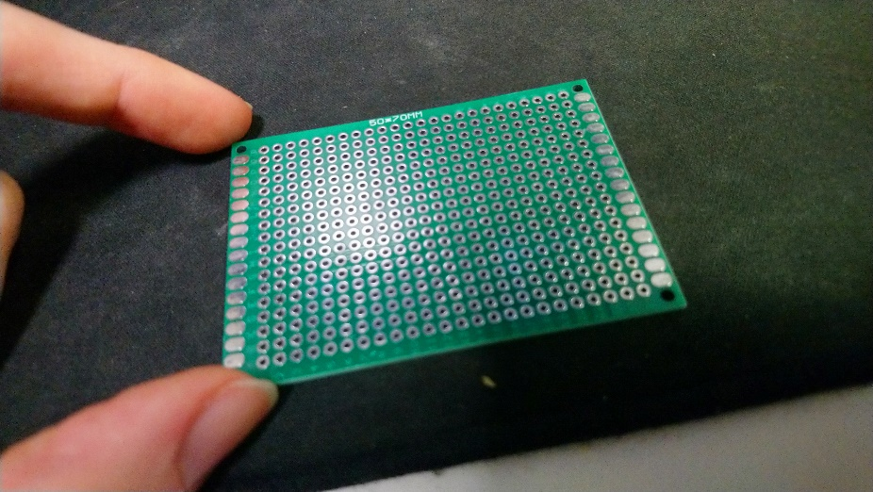obviously that amount of wires is not practile for a reasonable submission I need to miniaturise it and make it more robust.

Solution PCB, or more specifically a prototyping board. A DIY PCB. Here is a blank one. Basically I am going to translate the schematic onto this PCB

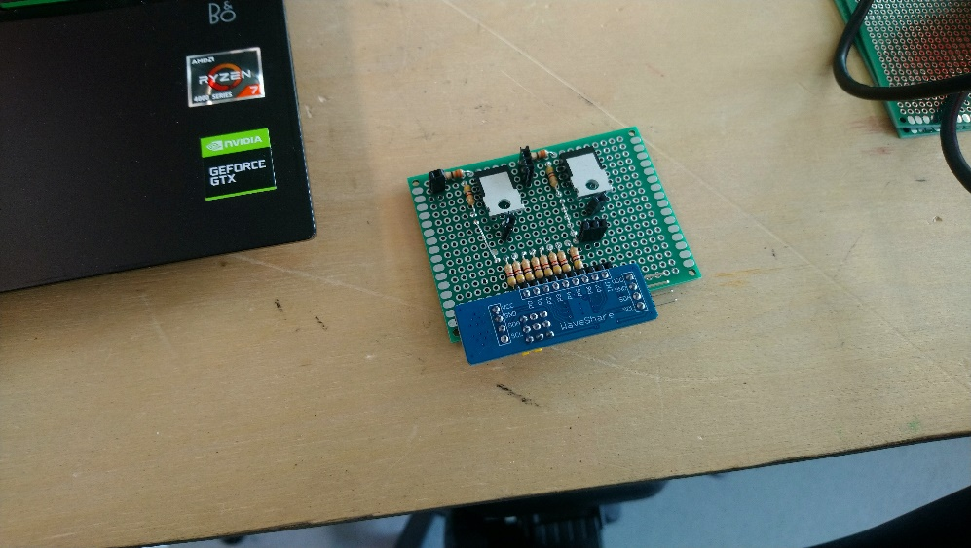This PCB is step one. I will refer to it as the interface board, this what all the cables coming from the gun will connect into.

Here you can see mounted the mosfets, their various resistors and the PCF8574 and its pulldown resistors.

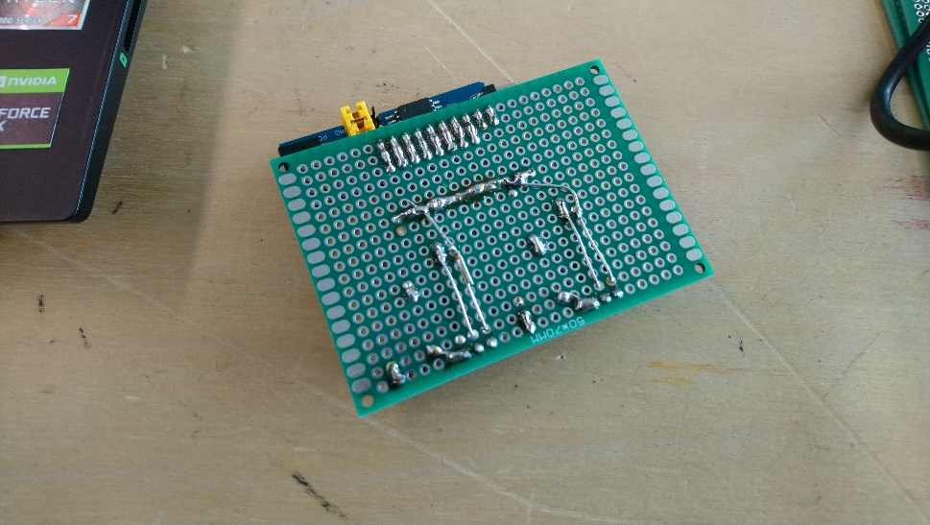

Back side of the interface board showing all the connections

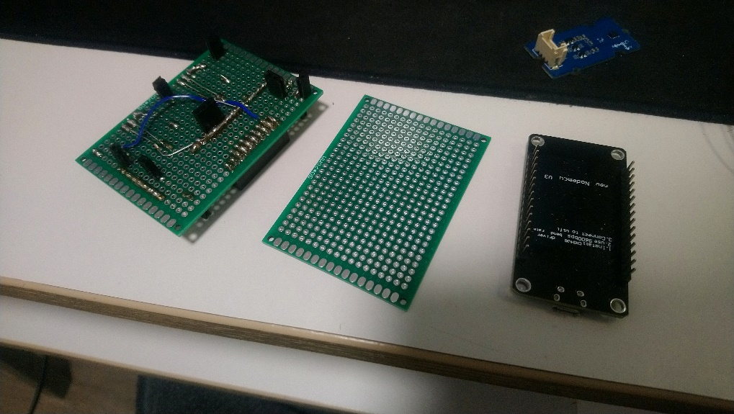The purpose of the PCB this is to eliminate as many wires as possible between the gun and the ESP8266 so the next step is a wiring board. This boards only purpose is to connect everything on the interface board(left) to the ESP8266 (right)

The little blue board is the 9DOF IMU (Gyro, accelerometer and compass)

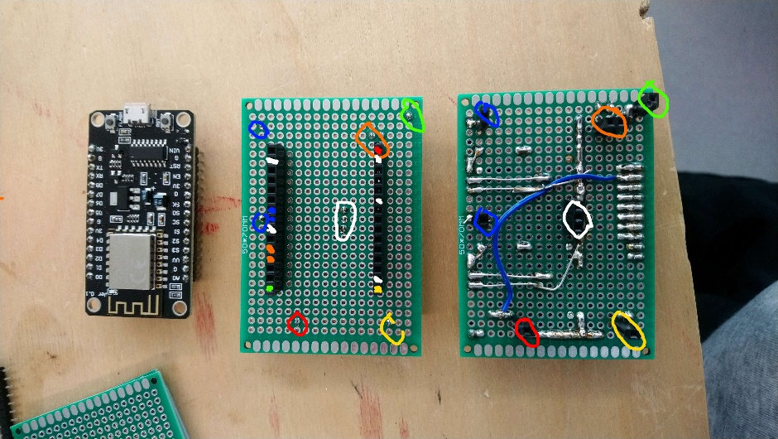The next 3 images so the development of this board.

ESP8266, wiring board, interface board (left to right)

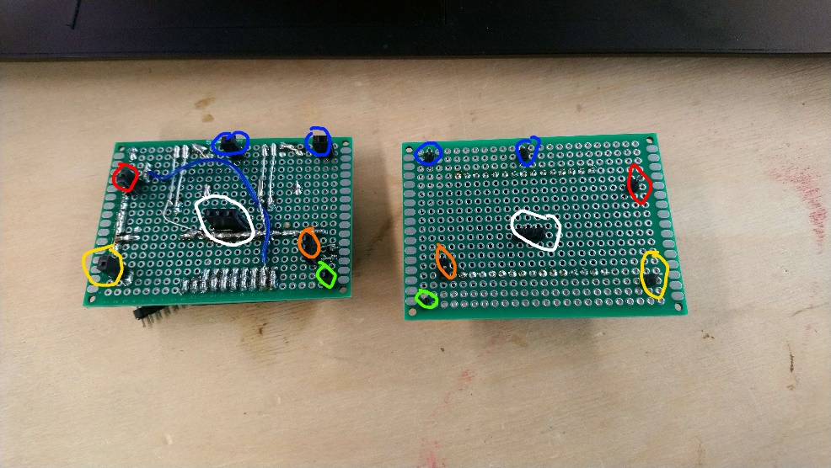Wiring board (Right)

Interface board (Left)

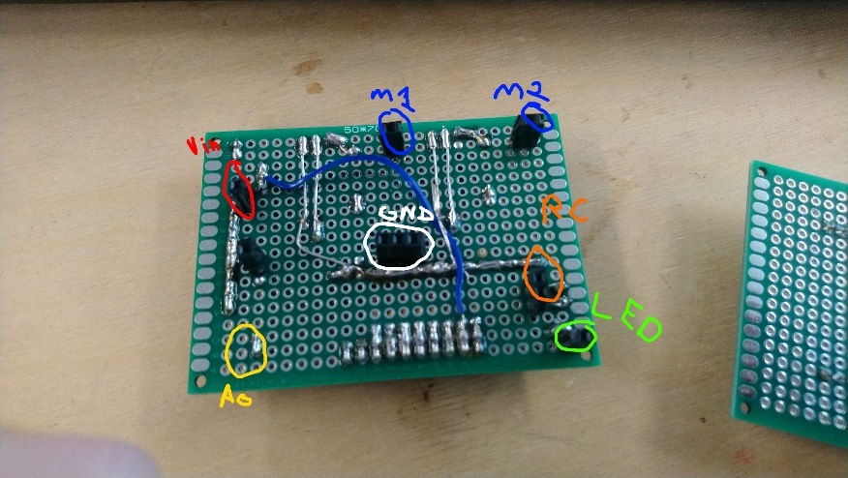

Better labelled interface board’s rear connectors.

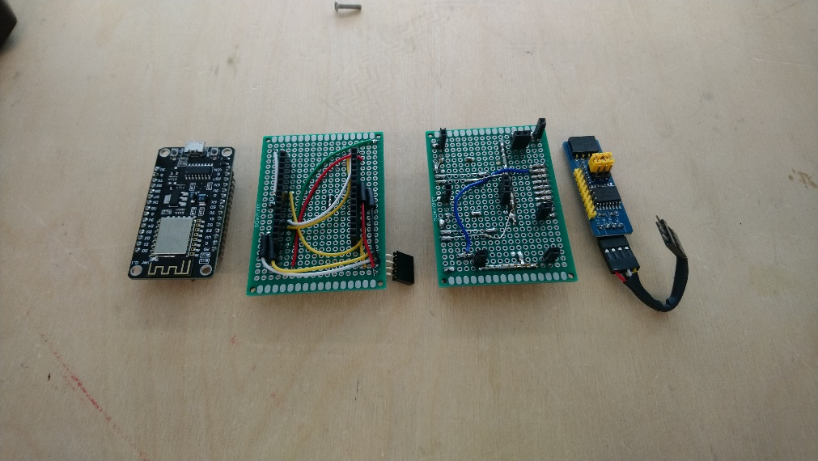Mostly complete ESP8266 wiring board, interface board and PCF8574 (left to right)

You can see now a number of wires running across the boards.

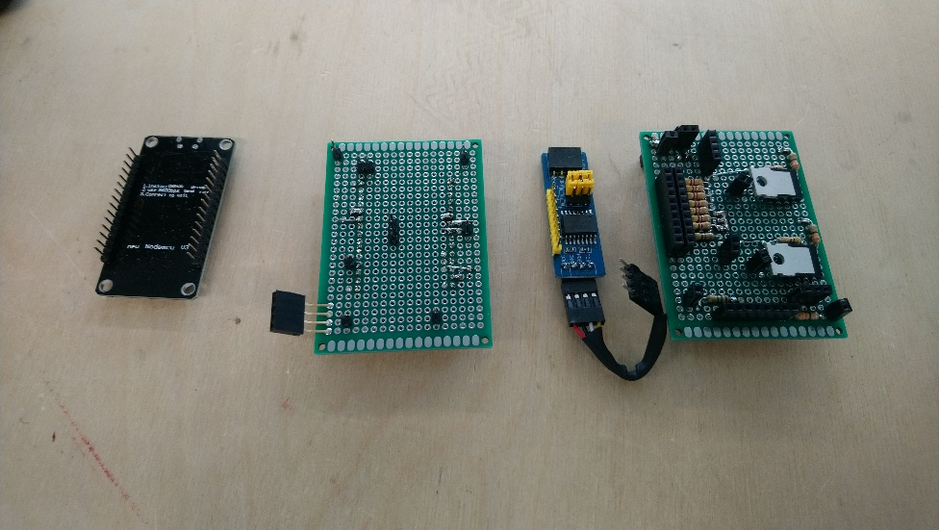Opposite sides of the above image

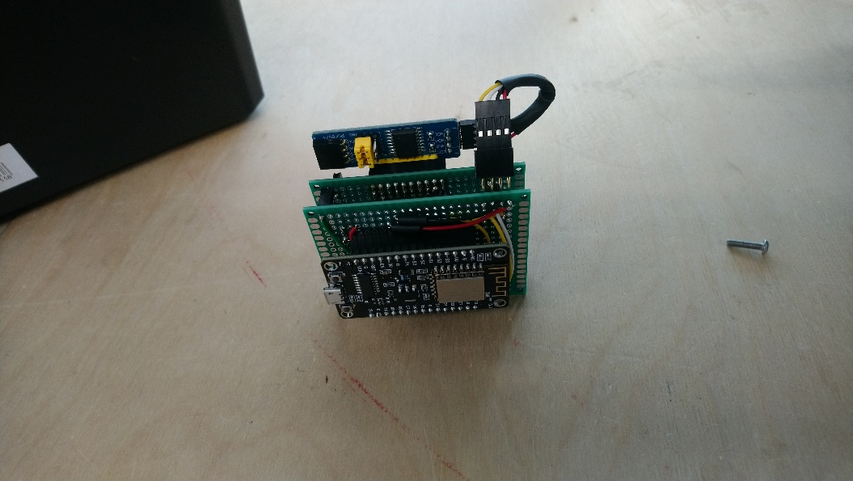

It stacks together into a nice PCB sandwich. Don’t eat it though, it contains lead.

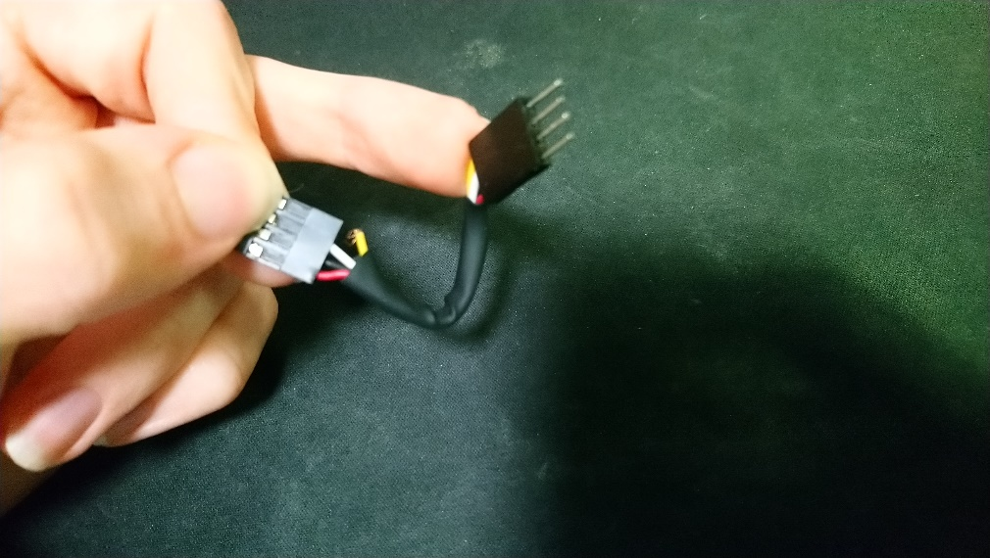the nice little cable I had connecting the i2c interface of the pcf8574 and the ESP8266 broke, before I noticed this it caused a great many problems. I just replaced it with some longer jumper cables that I tucked between the interface and wiring board.

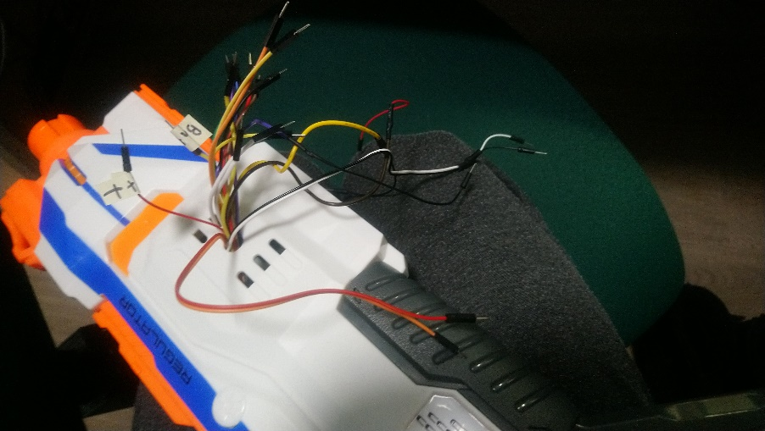I got Ben to drill a hole in the gun to pass wires out of.

They had labels but the fell off slightly. This allowed the gun to be closed up

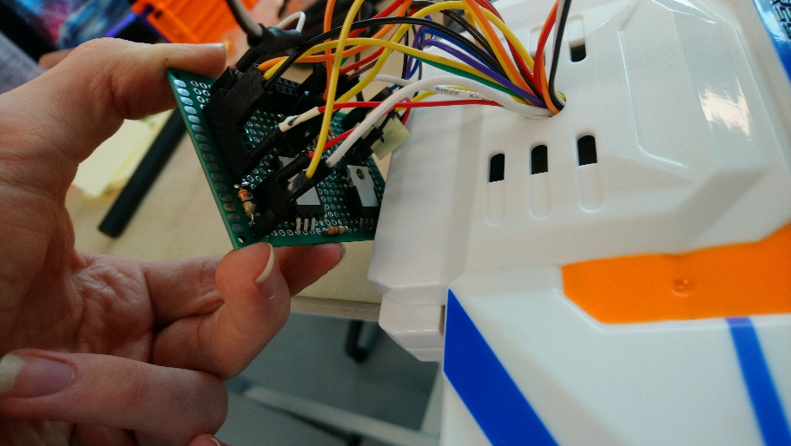testing out plugging everything from the gun into the interface board.

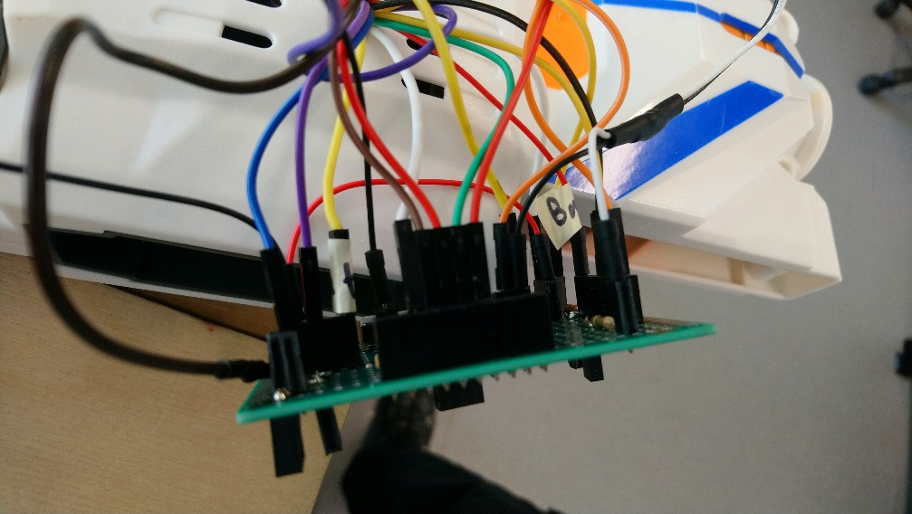

It doesn’t look great but think of the breadboard prototype..

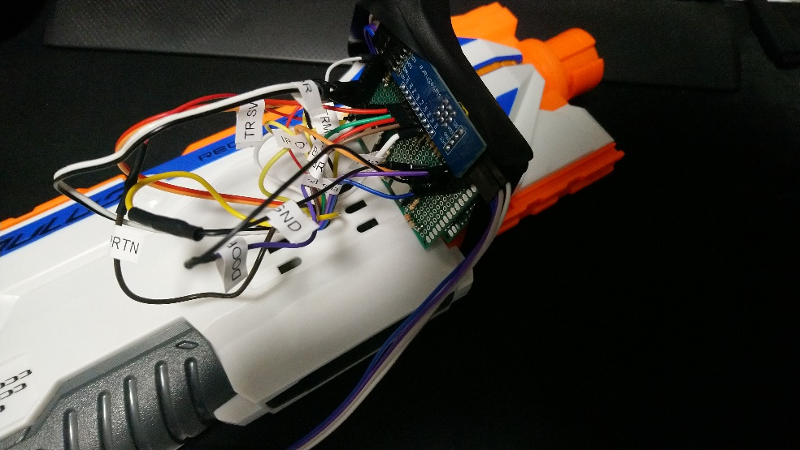Added the rest of the stack and some electrical table to keep it all in place.

Also new labels, that don’t fall off as muchTM

The long cable running off is for the IMU.

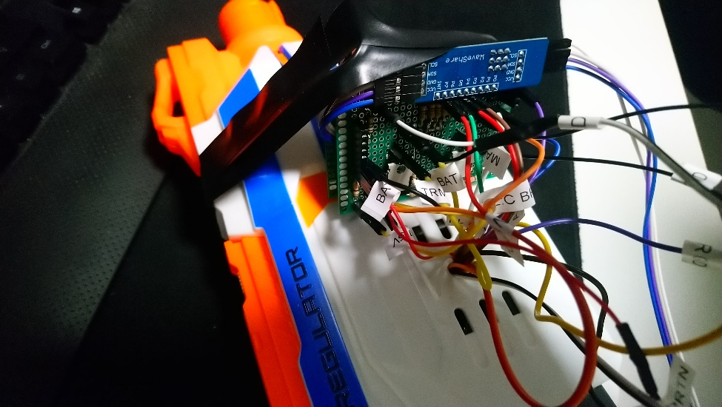

Chaos

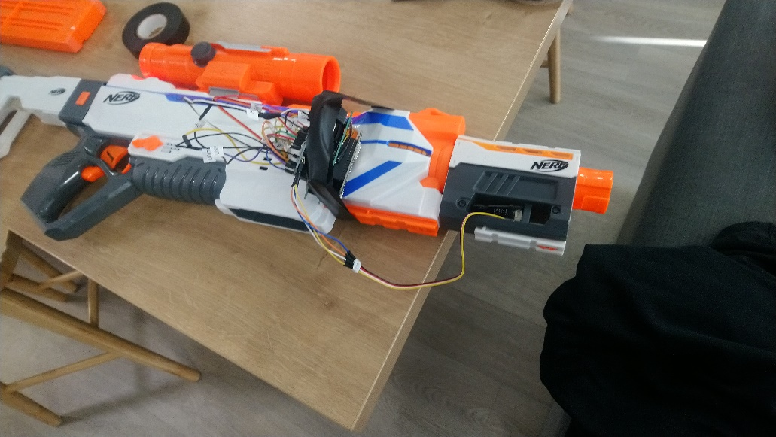

Full gun view now with the IMU attached to the barrel.

I later moved the IMU to the back of the stock – having it closer to the centre of rotation made it more accurate.

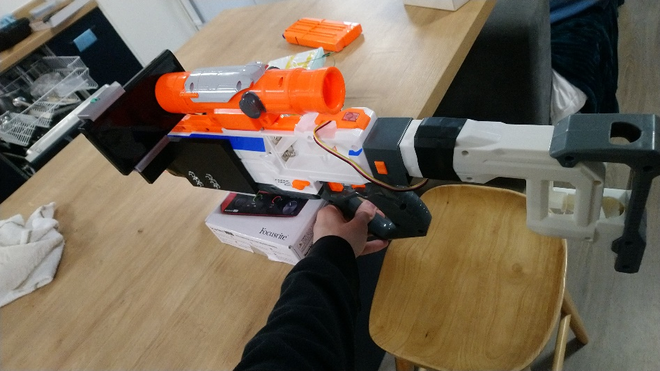Final physical prototype submitted with phone mounted.

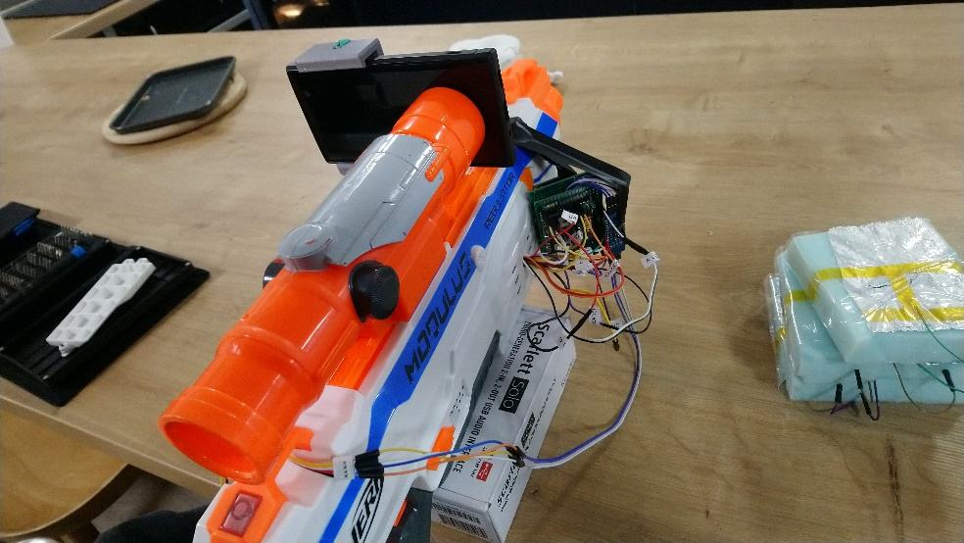The phone mounted is dead so is not displaying the game. I needed my phone to take these pictures.

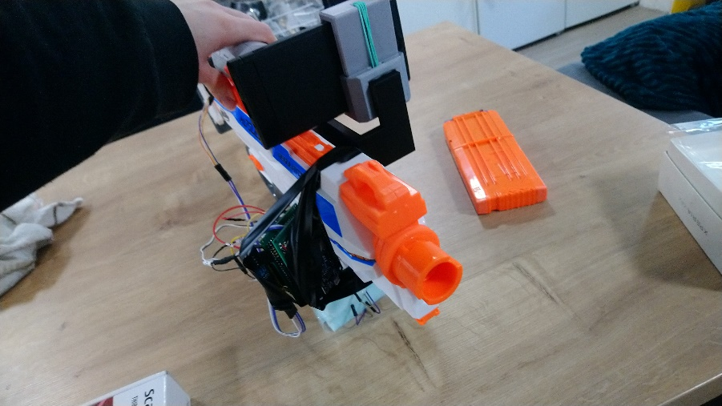

See the videos folder for evidence of the whole thing working.